MicroData and MetaData

# Program 1 Meta data:

<!DOCTYPE html>

<html lang="en">

<head>

    <meta charset="UTF-8">

    <meta name="viewport" content="width=device-width, initial-scale=1.0">

    <meta name="description" content="Explore the latest range of wireless headphones with advanced noise-canceling technology.">

    <meta name="keywords" content="Wireless Headphones, Noise Canceling, Bluetooth, AudioTech">

    <meta name="author" content="TechStore">

    <meta name="robots" content="index, follow">

    <meta http-equiv="refresh" content="10;url=https://example.com">

    <title>Metadata Example</title>

</head>

<body>

    <h1>Welcome to TechStore</h1>

    <p>Browse our collection of the latest headphones and accessories.</p>

</body>

</html>

# OutPut :

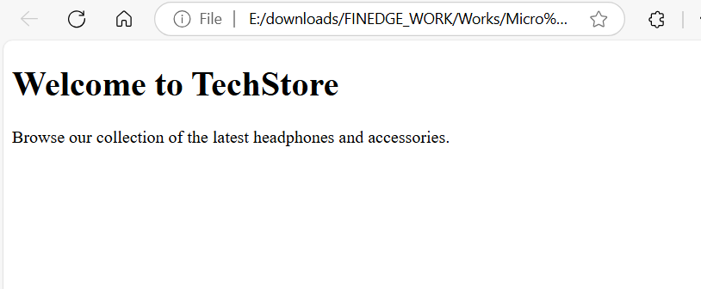

# Program 2 Meta Data :

<!DOCTYPE html>

<html lang="en">

<head>

    <meta charset="UTF-8">

    <meta name="viewport" content="width=device-width, initial-scale=1.0">

    <meta name="description" content="A portfolio website showcasing the projects, skills, and achievements of Jane Doe.">

    <meta name="keywords" content="Portfolio, Web Developer, Projects, Jane Doe">

    <meta name="author" content="Jane Doe">

    <meta name="theme-color" content="#007BFF">

    <meta property="og:title" content="Jane Doe - Portfolio">

    <meta property="og:description" content="Explore my projects and achievements as a web developer.">

    <meta property="og:image" content="https://example.com/janedoe-portfolio-thumbnail.jpg">

    <meta property="og:url" content="https://janedoeportfolio.com">

    <title>Portfolio - Jane Doe</title>

</head>

<body>

    <h1>Welcome to My Portfolio</h1>

    <p>Explore my work, skills, and achievements.</p>

</body>

</html>

# OutPut :

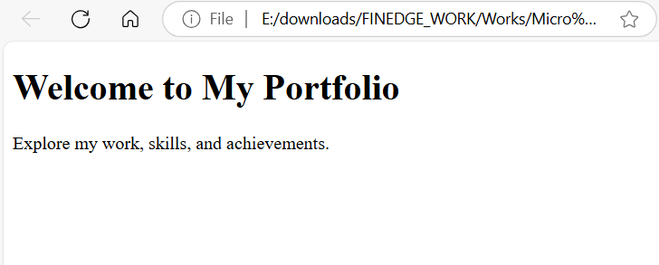

# Program 1 Micro Data :

<!DOCTYPE html>

<html lang="en">

<head>

    <meta charset="UTF-8">

    <meta name="viewport" content="width=device-width, initial-scale=1.0">

    <title>Microdata Example</title>

</head>

<body>

    <div itemscope itemtype="http://schema.org/Product">

        <h1 itemprop="name">Wireless Headphones</h1>

        <p itemprop="description">High-quality noise-canceling headphones with Bluetooth support.</p>

        <p>Price: <span itemprop="priceCurrency" content="USD">$</span><span itemprop="price">99.99</span></p>

        <p>Brand: <span itemprop="brand">AudioTech</span></p>

        <div itemprop="review" itemscope itemtype="http://schema.org/Review">

            <p>Review by: <span itemprop="author">John Doe</span></p>

            <p>Rating: <span itemprop="reviewRating" itemscope itemtype="http://schema.org/Rating">

                <span itemprop="ratingValue">4.5</span>/5</span></p>

        </div>

    </div>

</body>

</html>

# OutPut :

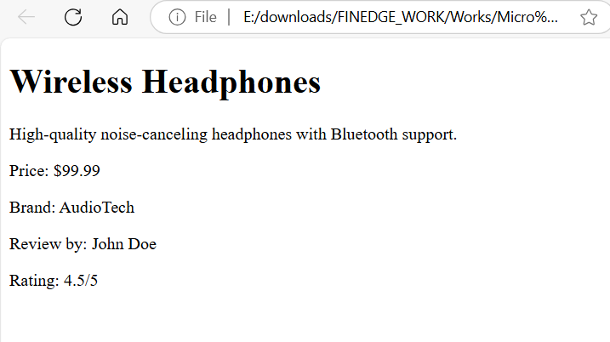

# Program 2 Micro Data :

<!DOCTYPE html>

<html lang="en">

<head>

    <meta charset="UTF-8">

    <meta name="viewport" content="width=device-width, initial-scale=1.0">

    <title>Microdata - Restaurant</title>

</head>

<body>

    <div itemscope itemtype="http://schema.org/Restaurant">

        <h1 itemprop="name">The Gourmet Kitchen</h1>

        <p>Location: <span itemprop="address" itemscope itemtype="http://schema.org/PostalAddress">

            <span itemprop="streetAddress">123 Foodie Street</span>,

            <span itemprop="addressLocality">Culinary City</span>,

            <span itemprop="addressRegion">Taste State</span></p>

        </p>

        <p>Serves Cuisine: <span itemprop="servesCuisine">Italian</span>, <span itemprop="servesCuisine">French</span></p>

        <p>Telephone: <span itemprop="telephone">+1-234-567-8900</span></p>

        <p>Opening Hours: <span itemprop="openingHours">Mon-Sat 9:00 AM - 10:00 PM</span></p>

        <div itemprop="aggregateRating" itemscope itemtype="http://schema.org/AggregateRating">

            <p>Rating: <span itemprop="ratingValue">4.7</span> out of 5</p>

            <p>Based on <span itemprop="reviewCount">150 reviews</span></p>

        </div>

    </div>

</body>

</html>

# OutPut :

